Life Cycle Plan (LCP)

Improving Thai CDC
Establishing a New Client/Donor/Partner Communications & Project Tracking Tool

Team #: 01

Team Members & Roles
Name | Primary/Secondary Role
Brandon Foster | IIV & V/Quality Focal Point
Ding Li | Life Cycle Planner/Software Architect
Yi Li | Feasibility Analyst/Requirements Engineer
Ino Mantaring | Requirements Engineer/Prototyper
Vishal Punjabi | Operational Concept Engineer/Prototyper
Katelyn Swift-Spong | Manager/Operational Concept Engineer
Charles Muckenthaler | IIV&V

12/05/2011

Version History
Date | Author | Version | Changes made | Rationale
09/28/2011 | Ding Li | 1.0 | Add development members' skill form | To identify team members' skills
10/07/2011 | Ding Li | 1.1 | Add assumptions and status of LCP, modified inconsistencies. | To identify purpose of LCP, explicit assumptions about clients,response to VCP evaluation
10/10/2011 | Ding Li | 2.0 | Assumptions updated, skills of development team updated | Document for FCP. To identify new skills learned by development team
10/14/2011 | Ding Li | 2.1 | Strategy, approaches and resources are define. | For Draft FCP
10/24/2011 | Ding Li | 3.0 | Content updated, bugs fixed, new team member added | For DCP
11/14/2011 | DL | 3.1 | Bugs fixed | To fixed some reported bugs
11/21/2011 | DL | 4.0 | Bugs fixed and re-estimated the project | For Draft TRR Package
12/05/2011 | DL | 4.1 | Bugs fixed | For TRR Package

Table of Contents
Life Cycle Plan (LCP) i
Version History ii
Table of Contents iii
Table of Tables iv
Table of Figures v
1. Introduction 1
1.1 Purpose of the LCP 1
1.2 Status of the LCP 1
1.3 Assumptions 1
2. Milestones and Products 2
2.1 Overall Strategy 2
2.2 Project Deliverables 3
3. Responsibility 6
3.1 Project-specific stakeholder’s responsibilities 6
3.2 Responsibilities by Phase 6
3.3 Skills 9
4. Approach 11
4.1 Monitoring and Control 11
4.2 Methods, Tools and Facilities 11
Resource 13

Table of Tables
Table 1: Deliverable Artifacts in Exploration Phase 3
Table 2: Deliverable Artifacts in Valuation Phase 3
Table 3: Deliverable Artifacts in Foundations Phase 4
Table 4: Deliverable Artifacts in Development Phase 5
Table 5: Responsibility for each Role 6
Table 6: Team Members’ Roles and Skill 9
Table 7: Tools used 12
Table 8: Scale Drivers of COTIPMO 13
Table 9: Estimated Application points 14

Table of Figures
Fig 1 screen shot of COTIPMO 14
Fig 2: actual effort 15
Fig 3 uncertainty cone 16

    - Introduction

Purpose of the LCP
This document, the Life Cycle Plan (LCP), will be used as the guideline for the entire project. It will identify the different types of artifacts each team member will deliver, describe the milestones shared by all stakeholders, and also identify the skills and responsibilities of each team member, as applicable to this project. With such a purpose, the LCP looks to ensure the entire project will meet all milestones, and deliver a system that is expected by the clients, development team, and USC staff.

Status of the LCP
The status of the LCP is currently at the Transition Readiness Review Package version number 4.0. In this version, we fixed bugs in last version and re-estimated the cost of project in COTIPMO

Assumptions
  - The duration of the project is 12 weeks.
  - Product is supposed to be delivered to client in the Fall semester of 2011.
  - The development-team members will not change during the 2011 Fall semester.
  - Main functions of the newly developed system will be supported by Network Centric Services (NCS).
  - Thai CDC does not employ Information Technology (IT) professionals.
  - The development team will spend at least 1 hour communicating with the client, Thai CDC, via meetings, teleconferences, info-sessions, etc... on a weekly basis.
  - Each member of the development team will work approximately 12 hours per week on the new system proposed by Thai CDC.
    - Milestones and Products

Overall Strategy
The Thai CDC Client/Donor/Partner Communications and Project Tracking Tool System is following Single NDI Process Pattern because most capabilities of this system must be built on single cloud-based web-services (Salesforce). The whole project is supported to be finished in 12 weeks. Our developing process is following ICSM.

There are 4 phases in our projects, they are listed as follow:

Exploration phase
Duration: 09/09/11- 09/28/11
Concept: The developer team will identify Operational Conception shared by all success-critical stakeholders; they will explore potential techniques to develop contacts management system and task tracking system of Thai CDC. They will study current system of Thai CDC and set time schedules and milestones of whole project
Deliverables: Valuation Commitment Package
Milestone: Valuation Commitment Review
Strategy: One Incremental Commitment Cycle
Valuation phase
Duration: 09/29/11- 10/14/11
Concept: In this phase, the development team will talk with clients and clarify their requirement and prioritize those requirements. The development team will have an agreement on win conditions with clients. The development team will develop the architecture of proposed system, operational concept, define the milestones.
Deliverables: Core Foundation Commitment Package, Draft Foundation Commitment Package, prototype, WinWin prioritization report.
Milestone: Foundation Commitment Review
Strategy: One Incremental Commitment Cycle
Foundation phase
Duration: 10/14/11- 10/24/11
Concept: Our project is a one-semester project, the development team only have a very short Foundation phase. In this phase, the development team will continue clarify clients' requirement and find out method to meet those requirement. The development team will also identify risks in development.
Deliverables: Draft Development Commitment Package,
Milestone: Development Commitment Review
Strategy: One Incremental Commitment Cycle
Development phase
Duration: 10/24/11-12/05/11
Concept: In this phase, the whole system will be developed and tested.
Deliverables: The final product, Test Procedure and Result. User Manual, Transition Readiness Review Package(TRR)
Milestone: Test Procedure and Result
Strategy: Two Incremental Commitment Cycles

Project Deliverables
Identify project deliverables in each phase and its due date, format, and medium

Exploration Phase

Table 1: Deliverable Artifacts in Exploration Phase
Artifact | Due date | Format | Medium
Client Interaction Report | 09/21/2011 | .doc, .pdf | Soft copy
Valuation Commitment Package  - Operational Concept Description (OCD) Early Section  - Life Cycle Plan (LCP) Early Section  - Feasibility Evidence Description (FED) Early Section | 09/28/2011 | .doc, .pdf | Soft copy
Evaluation of Valuation Commitment Package | 10/03/2011 | .xls | Soft copy
Project Effort | Every Monday | Text | ER system
Project Plan | Every Wednesday | .mpp, .pdf | Soft copy
Progress Report | Every Wednesday | .xls | Soft copy

Valuation Phase
Table 2: Deliverable Artifacts in Valuation Phase
Artifact | Due date | Format | Medium
Core Foundation Commitment Package  - OCD  - PRO  - WWPT  - SSAD section 1, 2.1  - LCP section 1, 3.3  - FED section 1, 3, 4.1, 4.2.1, 4.2.2  - SID | 10/10/2011 | .doc, .pdf | soft copy
Draft Foundation Commitment Package  - OCD  - PRO  - WWPT  - SSAD section 1, 2  - LCP  - FED section 1-5  - SID | 10/14/2011 | .doc, .pdf | soft copy
Response to Evaluation of Core FC Package | 10/14/2011 | Bugzilla | soft copy
Response to Evaluation of Draft FC Package | 10/24/2011 | Bugzilla | soft copy
Project Effort | Every Monday | Text | ER system
Project Plan | Every Wednesday | .mpp, .pdf | Soft copy
Progress Report | Every Wednesday | .xls | Soft copy

Foundations Phase
Table 3: Deliverable Artifacts in Foundations Phase
Artifact | Due date | Format | Medium
Development Commitment Package  - OCD  - PRO  - WWPT  - SSAD  - LCP  - FED  - SID  - QMP  - ATPC  - IP | 10/24/2011 | .doc, .pdf | soft copy
Project Effort | Every Monday | Text | ER system
Project Plan | Every Wednesday | .mpp, .pdf | Soft copy
Progress Report | Every Wednesday | .xls | Soft copy

Development Phase
Table 4: Deliverable Artifacts in Development Phase
Artifact | Due date | Format | Medium
Draft TTR Package  - OCD  - PRO  - WWPT  - SSAD section 1, 2  - LCP  - FED section 1-5  - SID  - IAR  - TP  - UM  - TM  - ATRP | 11/21/2011 | .doc, .pdf | soft copy
TTR Package  - OCD  - PRO  - WWPT  - SSAD section 1, 2  - LCP  - FED section 1-5  - SID  - IAR  - TP  - UM  - TM  - ATRP | 12/05/2011 | .doc, .pdf | soft copy
    - Responsibility

Project-specific stakeholder’s responsibilities
Table 5: Responsibility for each Role

Role | Responsibilities
Thai CDC Staff  (Client/User/Maintainer) | - Clarify needs and requirements  - Participate in the WinWin negotiation.  - Provide necessary assistance to development team.  - Give feedback to development team  - Track the process of project  - Test the project  - Get training from development team  - Maintain the system
USC student  (development team) | - Participate in WinWin session  - Analyze the current system of Thai CDC  - Investigate potential alternatives for development  - Develop prototype and define milestones and plan about project  - Develop the system based on agreement with clients  - Design the architecture of system and develop the system according to it.  - Train staff in Thai CDC
DEN Student  (IIV&V) | - Attend the WinWin sessions  - Monitor the process of project  - Feedback and review to development team  - Test the system.

Responsibilities by Phase

Table 5: Stakeholder's Responsibilities in Phase
Team Member / Role |  | Primary / Secondary Responsibility
 |  | Exploration | Valuation | Foundations | Development- Construction Iteration | Development- Transition Iteration
Katelyn Swift-Spong  Role:  - Manager,  - Operational Concept Engineer,  - Developer | Primary Responsibility  - Control and track the process of whole project.  - Leading communication with client  - Make project report  - Assign tasks to other members  Secondary Responsibility  - Find out what function and capabilities are needed by clients.  - Find out expected benefit of clients |  | Primary Responsibility  - Control and track the process of whole project.  - Leading communication with client  - Make project report  - Identify iteration  - Check all artifacts  - Make a more detailed plan  Secondary Responsibility  - Define new Operational Concept.  - Access defined operational concept  - Identify constrains of system | Primary Responsibility  - Control and track the process of whole project.  - Make project report  - Monitor the progress of project  Secondary Responsibility  - Improve the definition of operational concept  - Prepare for development | Primary Responsibility  - Control and track the process of whole project.  - Monitor the progress of project  - Develop the system  - Develop user manual  Secondary Responsibility  - Make project report | Primary Responsibility  - Control and track the process of whole project.  - Monitor the progress of project  - Develop user manual  Secondary Responsibility  - Make project report
Charles Muckenthaler  Role:  - IIV&V & | - Not in team yet |  | - Not in team yet. | - Not in team yet | Primary Responsibility  - Control the quality of whole system  Secondary Responsibility  - Help developing the system | Primary Responsibility  - Valuate and validate product  Secondary Responsibility  - Help developing the system
Brandon Foster  Role:  - IIV&V & Requirements Management | Primary Responsibility  - Have Winwin negotiate with clients  - Value and validate artifacts delivered by other team members.  Secondary Responsibility  - Contact with clients |  | Primary Responsibility  - Value and validate artifacts delivered by other team members.  - Make feedback to development team  Secondary Responsibility  - Help developing the system. | Primary Responsibility  - Value and validate artifacts delivered by other team members.  - Make feedback to development team.  Secondary Responsibility  - Help developing the system | Primary Responsibility  - Control the quality of whole system  - Develop the system  Secondary Responsibility  - Help make documentations | Primary Responsibility  - Valuate and validate product  Secondary Responsibility  - Help make documentations
Ino Mantaring  Role:  - Prototyper  - Requirements Engineer  - Developer | Primary Responsibility  - have a basic understanding of current system( MS Access System)  - Create conceptual prototype  Secondary Responsibility  - Search evidence of feasibilities.  - Discover clients' requirement |  | Primary Responsibility  - Create basically functional prototype  - Prioritize the requirement.  Secondary Responsibility  - Overview WinWin negotiation.  - Gather win condition  - Discover clients' requirement | Primary Responsibility  - Improve the functional prototype  - Prepare for development  Secondary Responsibility  - Evaluate the SSAD | Primary Responsibility  - Design and develop the whole system.  - Develop each component  - Fix defect  Secondary Responsibility  - Making user manual | Primary Responsibility  - Write user manual  Secondary Responsibility  - Transition Plan
Yi Li  Role:  - Feasibility Analyst  - Requirements Engineer | Primary Responsibility  - Evaluate risks of could-based system  - Evaluate risks and benefits of different type of approaches(Salesforce, et)  - Find out evidence to support the Feasibility report  Secondary Responsibility  - Search evidence of feasibilities.  - Discover clients' requirement |  | Primary Responsibility  - Evaluate risks of could-based system  - Evaluate approach  - Set evaluate criteria  Secondary Responsibility  - Evaluate and prioritize the requirement of clients  - Develop requirement definition.  - Build WWPT | Primary Responsibility  - Evaluate risks in development  - Evaluate approach  - Improve evaluate criteria  Secondary Responsibility  - Access the prototype | Primary Responsibility  - Test the project  Secondary Responsibility  - Help developing | Primary Responsibility  - Train Clients  Secondary Responsibility  - Archiving
Ding Li  Role:  - Life Cycle Planer  - Software Architect | Primary Responsibility  - Identify skills of each team member  - Identify responsibilities of each stakeholder in each phase  Secondary Responsibility  - Evaluate risks of could-based system  - Evaluate risks and benefits of different approaches |  | Primary Responsibility  - Identify new skills of each team member  - Identify responsibilities of each stakeholder in each phase  - Define plans and milestones  - Identity tools an d facilitate  Secondary Responsibility  - Define architecture of the project.  - Define context, artifacts and user case of project.  - Describe all use cases | Primary Responsibility  - Check the plan and milestones  - Record new skills, tools and facilitates  - Design iteration plan  Secondary Responsibility  - Access architecture of the project.  - Access context, artifacts and user case of project.  - Access NDI Interoperability | Primary Responsibility  - Plan each iteration  - Develop the System  Secondary Responsibility  - Access architecture of the project.  - Access context, artifacts and user case of project.  - Access NDI Interoperability | Primary Responsibility  - Access each iteration  Secondary Responsibility  - Making transition plan
Vishal Punjabi  Role:  - Operational Concept Engineer  - Prototyper  - Builder | Primary Responsibility  - Identify visions shared by all stakeholders  - Find out what function and capabilities does client want  Secondary Responsibility  - Help make the conceptual prototype |  | Primary Responsibility  - Define all operational concept  - Define constrains  - Define level of Goals  Secondary Responsibility  - Help develop functional prototype | Primary Responsibility  - Check all operational concept  - Check constrains  - Define level o Goals  - Prepare for development  Secondary Responsibility  - Help improve the functional prototype | Primary Responsibility  - Make training plan  Secondary Responsibility  - Develop the project | Primary Responsibility  - Training users and maintainers  Secondary Responsibility  - Help making user mannual
Chancee Martorell  Role:  - Main Client  - User  - Maintainer | Primary Responsibility  - Report needs to development team  - Provide information about current system  - Provide authority to development team  Secondary Responsibility  - Take meeting with development team |  | Primary Responsibility  - Track the progress of project  Secondary Responsibility  - Take meeting with development team | Primary Responsibility  - Track the progress of project  - Access the Development Commitment of development team  Secondary Responsibility  - Take meeting with development team | Primary Responsibility  - Track and test the system  Secondary Responsibility  - Take meeting with development team | Primary Responsibility  - Track and test the system  - Accept training from development team  Secondary Responsibility  - Take meeting with development team
Alexander R. Holsheimer  Role:  - Main Client  - User | Primary Responsibility  - Keep contacting with development team  - Take WinWin negotiation  - Report needs to development team  Secondary Responsibility  - Give development team information about clients' daily work |  | Primary Responsibility  - Keep contacting with development team  - Take WinWin negotiation  Secondary Responsibility  - Feed back to development team | Primary Responsibility  - Keep contacting with development team  - Take WinWin negotiation  Secondary Responsibility  - Feed back to development team | Primary Responsibility  - Track and test the system  Secondary Responsibility  - Feed back to development team | Primary Responsibility  - Track and test the system  Secondary Responsibility  - Accept training from development team
Maria Lam  Role:  - Main Client  - User | Primary Responsibility  - Keep contacting with development team  - Take WinWin negotiation  - Feedback to development team  Secondary Responsibility  - Feed back to development team |  | Primary Responsibility  - Keep contacting with development team  - Take WinWin negotiation  Secondary Responsibility  - Feed back to development team | Primary Responsibility  - Keep contacting with development team  - Take WinWin negotiation  Secondary Responsibility  - Feed back to development team | Primary Responsibility  - Track and test the system  Secondary Responsibility  - Feed back to development team | Primary Responsibility  - Track and test the system  Secondary Responsibility  - Accept training from development team
Pheel Wang  Role:  maintainer | Not involved in project yet |  | Not involved in project yet | Not involved in project yet | Not involved in project yet | Primary Responsibility  - Get training from development team  Secondary Responsibility  - Track the

Skills
Note: As the USC team continues their coursework in CSCI-577a (Software Engineering), each team member will acquire new skills that are pertinent to this project. These newly identified skills are listed in the "Skills" column below and can be identified by the square bullet-point.
Table 6: Team Members’ Roles and Skill
Team members | Role | Skills
Katelyn Swift-Spong | - Manager  - Operational Concept Engineer  - Developer | - Project Management  - MS project  - Salesforce configuration
Brandon Foster | - IIV&V & Requirements Management | - Communication skills  - Software Program Management,  - Software Testing \Requirements gathering,  - Win-book  - Bugzilla
Ino Mantaring | - Prototyper  - Requirements Engineer  - Developer | - problem solving and optimization  - Apex  - Salceforce API  - Balsamiq
Yi Li | - Feasibility Analyst  - Requirements Engineer  - Developer | - Software Testing Skills  - Communication Skill  - Salesforce configuration
Ding Li | - Life Cycle Planer  - Software Architect | - IBM RSM  - COTIPMO
Vishal Punjabi | - Operational Concept Engineer  - Prototyper  - Developer | - IBM RSM  - Salesforce configuration
Charles Muckenthaler | - IIV&V | - Bugzilla  - Software Testing Skill  - Quality Control Skill

    - Approach

Monitoring and Control
The progress of project will be monitored and controlled during the development. The purpose of monitoring and controlling is to ensure the quality of product and to finish all development in 12 weeks. We have weekly meeting , weekly effort report and weekly project plan to monitor the progress of project. We use bugzilla to control the quality of project.
In this Section, we will talk about Closed Loop Feedback Control methods and Reviews methods we used in projects.

Closed Loop Feedback Control
Our methods for closed loop feedback control are listed as follow:
- Effort Report: Everyone should write down how many hours spent on the project
- Progress Report: manager will record progress of the project every week, it helps the team meet the schedule.
- Project Plan: the Manger will use MS Project to set the baseline of project.
- Every one shares a dropbox for version control.
- Every one will keep in contact through email everyday.
- Weekly meeting: Development team will get together once every week to develop some important artifacts together.
- After class discussion: Development team will discuss some issues they have encountered after each class
- Google spreadsheet is used to share information.

Reviews
Our review methods are listed as following:
- Peer review in weekly meeting.
- We have TA review
- IIV&V reviews.
- Client Review

Methods, Tools and Facilities

Table 7: Tools used
Tools | Usage | Provider
Salesforce | NCS used to support most functionality in project | Web-service
Apex | Programming language and interface for Salesforce | Web-service
Winbook | To record win conditions in WinWin session | USC
spreadsheet | To prioritize requirement. | USC
Rational Software Modeler | Tool for UML working | IBM
Microsoft Project | To make baseline of project | Microsoft
Dropbox | Version control | Dropbox
Effort Report | To evaluate effort for each team member | USC
iCard | To identify the identity of team members | USC
MS office | To make report | Microsoft
Adobe reader | To generate pdf files | Adobe
gmail | To communicate with each outhers | Google
bugzilla | To track defects in project and resolution to them | USC
COCOMOII | To estimate the cost of project | USC
COTIPMO | For project estimation an team assessment | USC
Balsamiq | For prototyping | USC

Resource
The factors may influence the cost of our project are listed as below:
Effort Information;
Project duration: 12 weeks
CSCI577a Effort: 6 team members at 12 hrs/week for 12 weeks
CSCI577b Effort: N/A

Budget information:
It is a non-profit project, so there is no payment to development team. Salesforce provides free version to non-profit organization. However, the clients may need to pay maintain cost in the future, such as salaries for out-source technician.

Programming Language:
APEX: Programming language for Salesforce.
HTML
JavaScript

Modules
Contacts management
Mass mailing
Project tracking

Estimation Tool
COTIPMO, Our project is a NCS project. COCOMO II does not provide any model to estimate the cost of a NCS project. So we use model of our project in COTIPMO. Estimation factors and result are listed in table 8 , table 9 and fig 1.

Table 8: Scale Drivers of COTIPMO
Scale Driver | Value | Rationale
Reuse | 0% | We do not have a former system
Developer’s Experience and Capability | Nom | Nominal corresponds to the 55th percentile. Our developers are not experts at developing within and with NDI products, but we do have experience with software development.
Integrated Computer Aided Software Environment Maturity and Capability | Nom | The cloud-based CRM products we are considering using such as Salesforce come with developer Integrated Development Environments and tools for testing developed code.

Table 9: Estimated Application points
NSC details | Value | Rationale
screen | 11 simple | There are 11 screens in our project: 1. home page 2. contact list 3. add contact 4. donation list 5. add donation 6. project list 7. add project 8. setup page 9. user list page 10. add user page 11. data export page 12. email template. All of them are well supported by Salesforce and have only 3-4 views. So all of them are considered as simple..
report | 4 medium | There are 4 reports in our project: 1. Contacts report 2.donation 3.project 4.user. All of them have about 5-8 sections. So they are considered as medium
3GL | N/A | We do not develop any component in 3GL

Result of COTIPMO
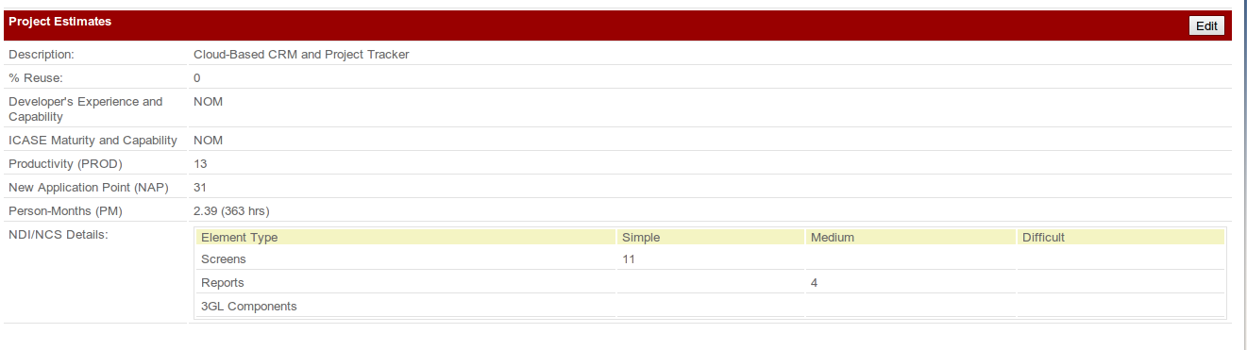
Fig 1 screen shot of COTIPMO

In our estimation, we need 2.39 PM to finish the whole project which indicates that our project is feasible in one semester.

Actual effort
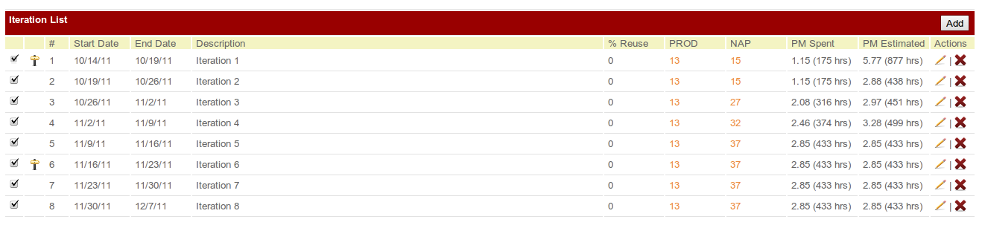
Fig 2: actual effort

In our development, we actually spent 2.85 PM to finish the whole project. We have exceeded the estimation a little because we developed 17 simple screens. Our project is finished on the iteration 5. The iteration 6, 7, 8 are transition iterations.
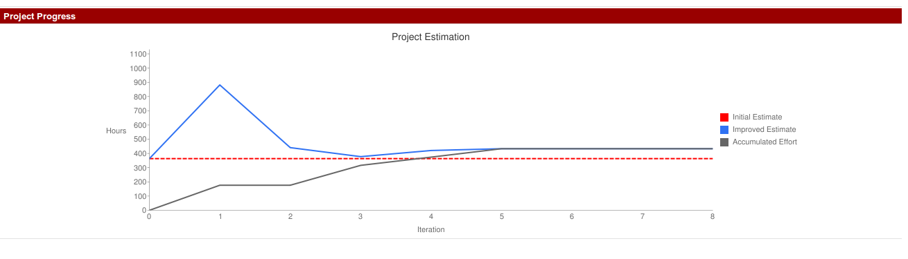
Fig 3 uncertainty cone
Our estimation became clear after the third iteration because most of our development is finished in the first three iterations. The result shows that our initial estimation is a little lower that our actual cost.

